IEEE Energy2030

Atlanta, GA USA
17-18 November, 2008

Control Strategies for Battery/Supercapacitor Hybrid Energy Storage Systems

Yu Zhang, Zhenhua Jiang, Xunwei Yu

Department of Electrical and Computer Engineering
University of Miami
Coral Gables, FL 33146 USA
Email: y.zhang24@umiami.edu; zjiang1@miami.edu; x.u1@umiami.edu

Abstract–Batteries are one of most cost-effective energy storage technologies. However, the use of batteries as energy buffers is somehow problematic, since it is hard, if not impossible, to recover from rapid power fluctuations without dramatically reducing the batteries’ lifetimes. In a supercapacitor, energy storage is by means of static charge rather than of an electrochemical process as in a battery; thus the supercapacitor has a higher power density than a battery. It is then advantageous to combine these two energy storage devices to accomplish better power and energy performances. This paper presents an active hybrid energy storage system that comprises a rechargeable battery, a supercapacitor bank and two corresponding DC/DC power converters. The battery and the super-capacitor may be charged or discharged simultaneously with the current or power appropriately split between them. The battery may be predominant in either the charging or discharging mode. Three different control strategies for power sharing between them are developed for the hybrid energy storage system. These control strategies are verified and compared against each other under some certain operating conditions. The effects of controller parameter variations on the system performance are also studied.

Index terms– Hybrid energy storage, power sharing, battery, supercapacitor, control

I. INTRODUCTON

Environmentally-friendly and renewable energy resources are becoming increasingly important in industrial, commercial and residential applications. Solar photovoltaic cells and wind generators are promising and gaining a great deal of attention [1]-[4], however, electric power generation from these sources is intermittent, depending on the weather conditions. Thus, in small autonomous renewable energy systems, energy storage is required in order to increase the response rate and power capacity of the power supply. They provide valuable benefits to improve stability, power quality and reliability of supply. On the other hand, many portable or automotive electronics have a common characteristic in their load profiles that they have a relatively low average power demand but a relatively high peak power requirement. The typical pulse duration with certain power levels in these specific applications generally ranges from hundreds of milliseconds to minutes. A quick load increase would cause a tremendous drop in the power source output voltage, which will deteriorate the power quality. In addition, in some extreme situation, the main power source itself can’t provide enough power to meet the peak power requirement [5]. Energy storage is necessary to increase the power density and specific power of these power sources.

Batteries are one of most cost-effective energy storage technologies. There are many control methods and they have a lot of applications [6]-[9]. However, the use of batteries as energy buffers is somehow problematic, since it is hard, if not impossible, to recover from fast power fluctuations without dramatically reducing the battery life time. The supercapacitor, which is like a regular capacitor with the exception that it allows very high energy density, in a small package, can solve this problem. Energy storage is by means of static electronic charge rather than of an electrochemical process of the battery, so a supercapacitor has higher power density than a battery. It is then advantageous to combine these two energy storage devices to gain better power and energy performances. The supercapacitor as a short-term energy storage device is utilized to compensate for fast changes in the output power, while the battery as a long-term energy storage device is applied to meet the energy demand [10]-[13].

As to the structure of hybrid energy storage systems, the active hybrids are more flexible than the passive hybrids which connects the power sources directly to the voltage bus

- In an active hybrid energy storage system, a dc/dc power converter is placed between each energy device and the output terminal so that the power sharing between all energy storage devices can be actively controlled [15]-[17]. Hybrid energy storage can find many applications, from portable electronics, to hybrid electric vehicles, to renewable power generation systems. Although some hybrid power sources such as fuel cell/battery, fuel cell/supercapacitor, etc, have been studied [18]-[21], controlling active hybrid battery/supercapacitor energy storage systems is still an open question.

In this paper, the hybrid energy storage system is studied that comprises a battery and a super capacitor as well as a main power source, which are connected to the same voltage bus through appropriate DC-DC power converters. While the main power source aims to supply mean power to the load, the battery and supercapacitor, as energy storage devices, supply transient power and peak load demand. The supercapacitor can provide peak power with a faster response than the battery, but it lasts shorter than the battery. So the battery discharges and charges some amount of peak power, and if necessary, trigger the supercapacitor to supply or accept excess peak power to limit the battery current. In the following, Section II presents the structure of the hybrid energy storage system snd several

control strategies for power sharing between the energy storage devices. In Section III, these control strategies are verified and compared against each other through simulation. The effects of controller parameter variations on the system performance are studied in Section IV.

- HYBRID ENERGY STORAGE SYSTEM AND CONTROL SYSTEM

Fig. 1 schematically shows the structure of the proposed active hybrid energy storage that comprises a battery and a supercapacitor bank. These two energy storage devices are connected to a common DC voltage bus through two corresponding DC/DC power converters. Generally, the active hybrid energy storage system is used together with a main power source whose function is to provide average power to the load. The load is directly connected to the DC voltage bus through appropriate power converters. The battery and supercapacitor, as energy buffers, provide transient power and peak load requirement.
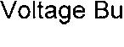
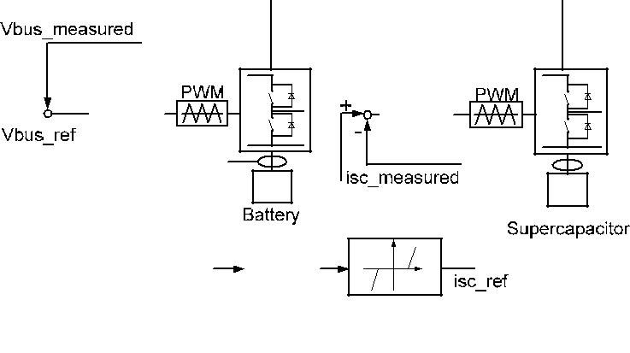
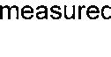
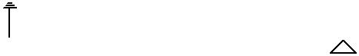




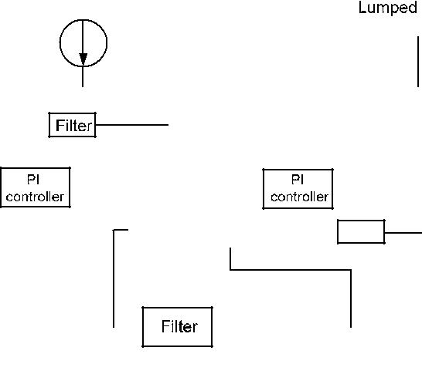


Fig. 1. Control loops for the power converters

Fig. 2 shows an application of the hybrid energy storage system in a hybrid power supply system, which comprises a main power source, which could be fuel cells in the hybrid vehicles or in the portable devices or internal combustion engine in car, etc, and an active hybrid battery/supercapacitor energy storage system. As the main power source is not current reversible, a boost converter is chosen to adapt the low DC voltage output from the main power source to regulate bus voltage. Because the power may flow through the battery and supercapacitor in both directions, a bi-directional dc/dc power converter is selected for each of them.

By controlling the converters placed between the energy storage devices and the voltage bus, the power sharing between them can be managed. Fig. 1 also shows the control system for the power converters. The control for the battery is to maintain the bus voltage at the voltage reference. The control regulation loops for the supercapacitor are to regulate

the output current depending on the battery output current. Its power converter is controlled by an inner control loop, in order to have a fast response, and an outer control loop that produces the reference for the inner loop. There are three control strategies shown as Fig. 3, which can cover most different control situations.
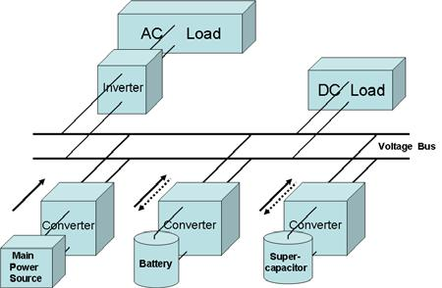

Fig. 2. Architecture of the proposed hybrid power supply

Control strategy A: when the load demand is high, the battery discharges first. When the battery output current reaches a threshold ib1, the supercapacitor starts to discharge. On the other hand, when the load demand is low, the battery and the supercapacitor are charged together. The charging current to the supercapacitor is dynamically determined according to the charging current to the battery. Therefore, the power is shared by the battery and supercapacitor following a certern pattern, which will be discussed later.
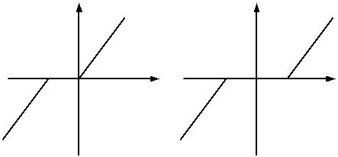


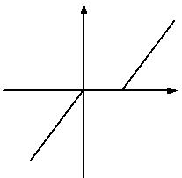


- isc is the output current of supercapacitor

- ib is the output current of battery
- ib1, ib2 are the battery current threshold values

Fig. 3. Three control strategies for power sharing between the battery and supercapacitor

Control strategy B: the battery and the supercapacitor discharge at the same time when the load demands high power. When the load demand is low, the battery is charged first. When the battery charging current reaches another threshold ib2, the supercapacitor starts to be charged. The current of the supercapacitor is also regulated by the current of the battery.

Control strategy C: the battery discharges first. When the battery current reaches theshold ib1, the supercapacitor starts to discharge. On the other hand, the battery is charged first. When the battery charging current reaches threshold ib2, the supercapacitor starts to be charged.

It is worth to note that the slopes of the lines in Fig. 3. determine the power ratio shared by each energy storage device. Taking strategy A for example, Fig. 4 shows different situations as the slopes change, which will affect the system performance. The current sharing rates, determined by the slopes of the two lines in each figure, are important design parameters in the control strategy, which will be studied in Section IV.

isc |  |  | isc |  |  |  | isc
 | K1 |  |  |  | K3 |  |  |  | K5
 |  | ib |  |  |  | ib |  |  |  | ib
K2 | ⁰ ib1 | ib |  | 0 |  | ib |  | 0 |  | ib
K2 |  |  | K4 |  |  |  | K6
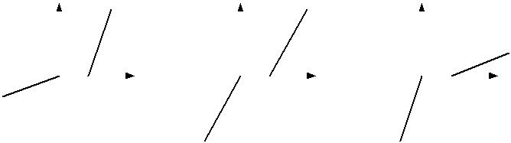

Fig. 4. Parameter changes under Control Strategy A.

III. VERIFICATION OF CONTROL STRATEGIES

To verify and compare the performance of the three control strategies, the hybrid energy storage system is modeled and simulated in the context of a hybrid power supply, which is shown in Fig. 5. The battery is configured as 64 in series and 25 in parallel. The nominal capacity of each cell is 1.4 Ah. The initial state-of-charge of the battery is set as 60%. The super-capacitor model configured as 20 in series and 20 in parallel represents a 2000 F Maxwell supercapacitor bank with a 300 V rated voltage. The parameter setting is listed in Table I. We use a DC voltage source to represent a main power source, which is fuel cell in our case. Four different loads were chosen to test the three control strategies.
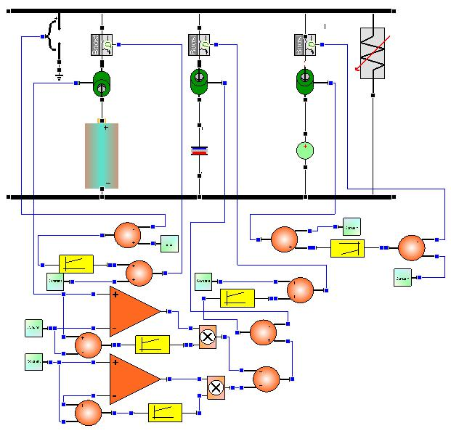

Fig. 5. VTB schematic view of the hybrid power system

The proposed control strategy is mentioned before, and the reference for bus voltage is set as 500 V. The parameters in control strategies delivered before are given as follows:

ib1=20, ib2=-5, K1=5, K2=1, K3=3, K4=3, K5=1, K6=5.

Table I. Parameters for the hybrid power supply in the simulation

BATTERY PARAMETERS

Capacity per cell |  | 1.4 Ah
Initial SOC |  | 0.6
Battery Array |  | Parallel:25 | Series:64
V_{bus} reference |  | 500 V
 | S | UPERCAPACITOR PARAMETERS
Supercapacitor Array |  | Parallel:20 | Series:20
Nominal Voltage |  | 300 V
Total Capacitance |  | 2000 F
Battery Current |  | ib1=20 A, ib2=-5 A
threshold values
MAIN POWER SOURCE PARAMETERS
Nominal Voltage |  | 200 V
Current reference |  | 60 A

The simulation runs for 2 hours. The load demand is chosen to be a repetitive load with a period of 1 hour, as shown in Fig.

- The power demand exhibits stepwise progression in each period, which is changing from about 4kW to 9kW, 15kW and 20kW with duty cycles of 5%, 45%, 45% and 5% respectively. The main power source output current is maintained at 60 A, so its output power is about 10kW.

2. | x 10⁴
2. | 2
 | 2 |  |  |  |  |  | Control strategy A
 | 2 |  |  |  |  |  | Control strategy B
1. | 8 |  |  |  |  |  | Control strategy C
1. | 6
1. | 4
1. | 2
Load | 1
0. | 8
0. | 6
0. | 4
0. | 2
 | 0₀ | 1000 | 2000 | 3000 | 4000 | 5000 | 6000 | 7000
 |  |  |  |  | t
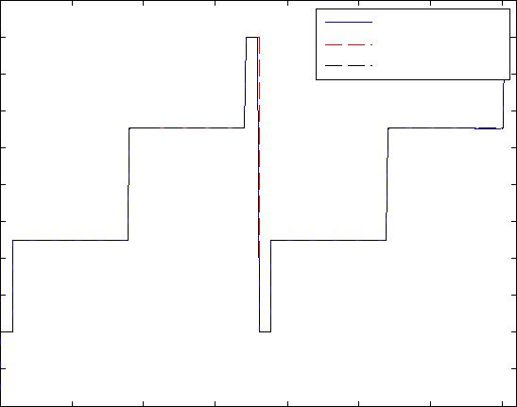

Fig. 6. Load demand profile for testing of three control strategies

The simulation results under three power sharing strategies are shown in Fig. 7. The DC bus voltage is maintained at 500V by controlling the duty cycle of the bi-directional power converter of the battery shown in Fig. 7-(a). Figs. 7-(b) and 7-(c) show the battery and supercapacitor output currents under the three control strategies. Figs. 7-(d) and 7 -(e) show the nominal voltages of battery and supercapacitor. Fig. 7-(f) shows that the different states of charge of battery under these three power sharing strategies. Figs. 7-(g), 7-(h) and 7- (i) show the zoomed versions of the bus voltage and the output currents of the battery and the supercapacitor.

 | 510
 | 508 |  |  |  |  |  | Control strategy A
 | 508 |  |  |  |  |  | Control strategy B
 | 506 |  |  |  |  |  | Control strategy C
 | 504
Vbus(V) | 502
Vbus(V) | 500
 | 498
 | 496
 | 494
 | 492
 | 490₀ | 1000 | 2000 | 3000 | 4000 | 5000 | 6000 | 7000
 |  |  |  |  | t(s)
 |  |  | (a) DC bus voltage
 | 350
 |  |  |  |  |  | Control strategy A
 |  |  |  |  |  | Control strategy B
 | 300 |  |  |  |  | Control strategy C
 | 250
Vb(V)
 | 200
 | 150
 | 100₀ | 1000 | 2000 | 3000 | 4000 | 5000 | 6000 | 7000
 |  |  |  |  | t(s)
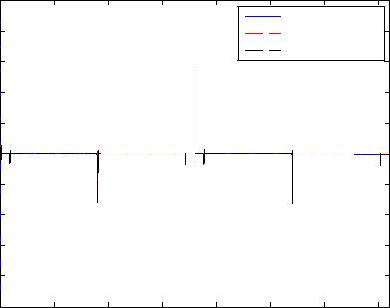
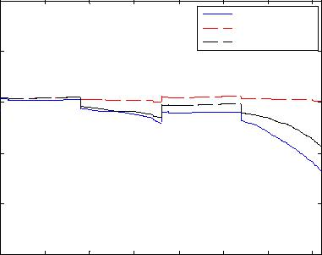

 | 40
 |  |  |  |  |  |  |  | Control strategy A
 |  |  |  |  |  |  |  | Control strategy B
 | 30 |  |  |  |  |  |  | Control strategy C
 | 20
Ib(A) | 10
 | 0
 | -10
 | -20₀ |  | 1000 | 2000 | 3000 | 4000 | 5000 | 6000 | 7000
 |  |  |  |  |  | t(s)
 |  |  | (b) Current of the battery
 | 350
 | 340 |  |  |  |  |  |  | Control strategy A
 | 340 |  |  |  |  |  |  | Control strategy B
 | 330 |  |  |  |  |  |  | Control strategy C
 | 320
Vsc(v) | 310
Vsc(v) | 300
 | 290
 | 280
 | 270
 | 260
 | 250 | 0 | 1000 | 2000 | 3000 | 4000 | 5000 | 6000 | 7000
 |  |  |  |  |  | t(s)
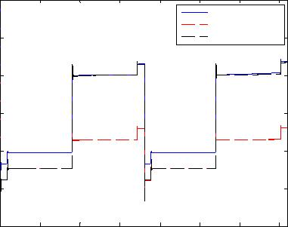
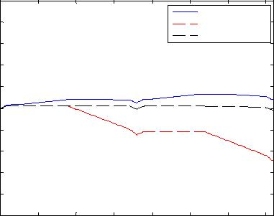

 | 50
 |  |  |  |  |  |  |  | Control strategy A
 | 40 |  |  |  |  |  |  | Control strategy B
 |  |  |  |  |  |  |  | Control strategy C
 | 30
 | 20
Isc(A) | 10
Isc(A) | 0
 | -10
 | -20
 | -30
 | -40₀ |  | 1000 | 2000 | 3000 | 4000 | 5000 | 6000 | 7000
 |  |  |  |  |  | t(s)
 |  |  | (c) Current of the supercapacitor
 | 1
 | 0.9 |  |  |  |  |  |  | Control strategy A
 | 0.9 |  |  |  |  |  |  | Control strategy B
 | 0.8 |  |  |  |  |  |  | Control strategy C
battery | 0.7
battery | 0.6
of | 0.6
of | 0.4
ofcharge | 0.4
 | 0.5
State | 0.3
 | 0.2
 | 0.1
 | 0 | 0 | 1000 | 2000 | 3000 | 4000 | 5000 | 6000 | 7000
 |  |  |  |  |  | t
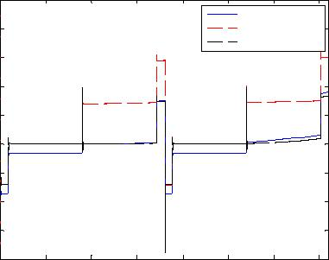
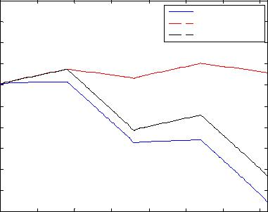

(d) Voltage of the battery

500.5 Control strategy A
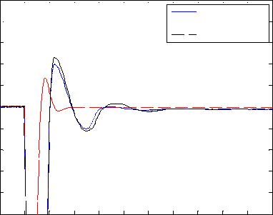
^{500.4} Control strategy B
Control strategy C

500.3

 | 500.2
Vbus(V) | 500.1
Vbus(V) | 500
 | 499.9
 | 499.8
 | 499.7
 | 499.6
 | 499.5 | 1800 | 1810 | 1820 | 1830 | 1840 | 1850 | 1860 | 1870 | 1880 | 1890 | 1900
 | 1790
t(s)

(e) Voltage of the supercapacitor |  |  |  |  |  |  |  |  |  |  |  | (f) Calculated state-of-charge of the battery
25 |  |  |  |  |  |  |  |  |  |  |  | 20
 |  |  |  |  |  |  |  | Control strategy A |  |  |  |  |  |  |  |  |  |  |  | Control strategy A
 |  |  |  |  |  |  |  | Control strategy B |  |  |  |  |  |  |  |  |  |  |  | Control strategy B
 |  |  |  |  |  |  |  | Control strategy C |  |  |  | 15 |  |  |  |  |  |  |  | Control strategy C
20 |  |  |  |  |  |  |  |  |  |  |  | 15
15 |  |  |  |  |  |  |  |  |  |  |  | 10
15 |  |  |  |  |  |  |  |  |  |  |  | Is c(A)
Ib(A) |  |  |  |  |  |  |  |  |  |  |  | Is c(A)
 |  |  |  |  |  |  |  |  |  |  |  | 5
10
 |  |  |  |  |  |  |  |  |  |  |  | 0
5
1790 | 1800 | 1810 | 1820 | 1830 | 1840 | 1850 | 1860 | 1870 | 1880 | 1890 | 1900 | -5 | 1800 | 1810 | 1820 | 1830 | 1840 | 1850 | 1860 | 1870 | 1880 | 1890 | 1900
 |  |  |  |  |  |  |  |  |  |  |  | 1790
 |  |  |  |  | t(s) |  |  |  |  |  |  |  |  |  |  |  | t(s)
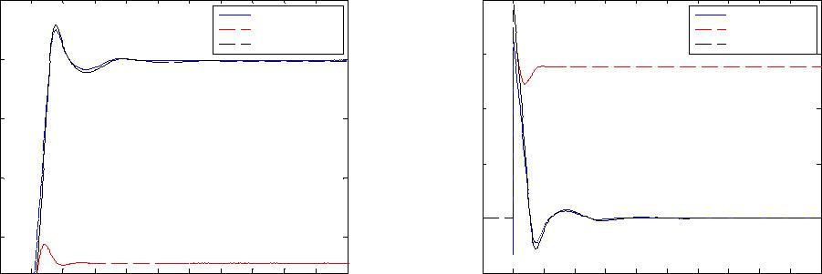

(g) Zoomed version of bus voltage (h) Zoomed version of battery current (i) Zoomed version of supercapacitor current Fig. 7. Simulation results for the hybrid energy storage system under three control strategies

Initially under a light load of about 4kW, the battery and supercapacitor start to be charged together at the same time with different current sharing rates in these three strategies. When the load demand increases to 9 kW, under Strategy A, the battery and supercapacitor are still charged together; but under Strategy B and Strategy C, only the battery is charged and the supercapacitor is not charged. The battery charging current is about 0.5 A, 4.5 A, 4.5 A respectively. Under a 15 kW load demand, the battery starts to discharge but the supercapacitor doesn’t under Strategy A and Strategy C; they discharge together at the same time under Strategy B. When the load reaches a peak value (20 kW), the battery and supercapacitor discharge together under all the three strategies.

Simulation results show that the battery charge is increased after 2 hours of operation under Strategy B while the battery charge is decreased with the other two strategies. Therefore, under strategy B, the battery would eventually be depleted

under the repetitive load. The battery loses more charge under the same load under Strategy A than under Strategy C. This is because the battery discharges more current under Strategy A.

IV. EFFECTS OF CONTROLLER PARAMETER

VARIATIONS

As mentioned before, the current sharing ratio between the two energy storage devices is determined by the slope of the piecewise lines in the control strategies. The effect of the power sharing ratio as set by the controller on the system performance is also studied. Strategy A is taken for example and the control strategy is evaluated under three sets of control parameters, shown in Fig. 4:

Condition 1: K1 = 5, K2 = 1,

Condition 2: K3 = 3, K4 = 3,

Condition 3: K5 = 1 and K6 = 5.

The simulation is with three different load changes, which can be enough to cover different conditions of the first power sharing control strategy. The load change repeat period is 1 hour as shown in Fig. 8. It changes from about 4kW to 9kW, 15kW and 20kW, with respective duty cycles of 45%, 10% and 45%. The main power source output current is maintained at 60A, so its output power is about 10kW.

The simulation for this hybrid energy storage system runs for 2 hours. Simulation results are shown in Fig. 9. Fig. 9-(a) shows that the bus voltage is regulated at a constant value with very small fluctuations. While Figs. 9-(b) and 9-(c) show the currents of the battery and supercapacitor under the three control strategies, Figs. 9-(d) and 9-(e) show their respective voltages. Fig. 9-(f) demontrates that the battery loses least charge after 2 hours operation in Condition 1 compared with other two conditions. This is because the battery gets most charging current and discharges the least current in Condition 1. Figs. 9-(g), 9-(h) and 9-(i) show the zoomed versions of the

bus voltage and the currents of the battery and the supercapacitor. It is seen that the repsonses of these currents and voltage are fast and overshoots are small.

 | _{2.2} x 10⁴
 | 2 |  |  |  |  |  |  | Condition 1
 | 2 |  |  |  |  |  |  | Condition 2
 | 1.8 |  |  |  |  |  |  | Condition 3
 | 1.6
 | 1.4
Load | 1.2
Load | 1
 | 0.8
 | 0.6
 | 0.4
 | 0.2
 | 0 | 0 | 1000 | 2000 | 3000 | 4000 | 5000 | 6000 | 7000
 |  |  |  |  |  | t
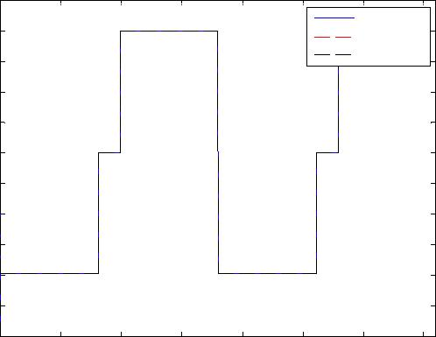

Fig. 8 Load demand profile for studying the effect of controller parameters.

 | 550
 | 540 |  |  |  |  |  | Condition 1
 | 540 |  |  |  |  |  | Condition 2
 | 530 |  |  |  |  |  | Condition 3
 | 520
 | 510
Vbus(V) | 500
Vbus(V) | 490
 | 480
 | 470
 | 460
 | 450₀ | 1000 | 2000 | 3000 | 4000 | 5000 | 6000 | 7000
 |  |  |  |  | t(s)
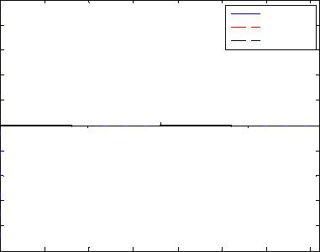

(a) DC bus voltage

 | 260
 | 258 |  |  |  |  |  | Condition 1
 | 258 |  |  |  |  |  | Condition 2
 | 256 |  |  |  |  |  | Condition 3
 | 254
 | 252
Vb(V) | 250
 | 248
 | 246
 | 244
 | 242
 | 240₀ | 1000 | 2000 | 3000 | 4000 | 5000 | 6000 | 7000
 |  |  |  |  | t(s)
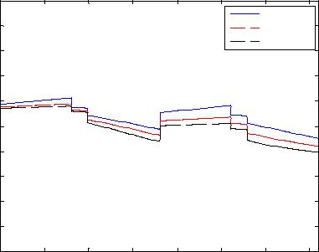

(d) Voltage of the battery

 | 501
 | 500.8 |  |  |  |  |  |  |  | Condition 1
 | 500.8 |  |  |  |  |  |  |  | Condition 2
 | 500.6 |  |  |  |  |  |  |  | Condition 3
 | 500.4
 | 500.2
Vbus(V) | 500
Vbus(V) | 499.8
 | 499.6
 | 499.4
 | 499.2
 | 499 | 1610 | 1620 | 1630 | 1640 | 1650 | 1660 | 1670 | 1680 | 1690 | 1700
 | 1600
 |  |  |  |  |  | t(s)
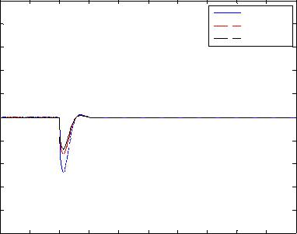

 | 40
 |  |  |  |  |  |  | Condition 1
 |  |  |  |  |  |  | Condition 2
 | 30 |  |  |  |  |  | Condition 3
 | 20
Ib(A) | 10
 | 0
 | -10
 | -20₀ | 1000 | 2000 | 3000 | 4000 | 5000 | 6000 | 7000
 |  |  |  |  | t(s)
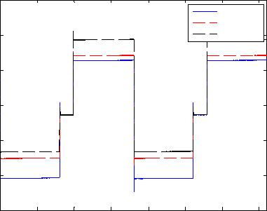

(b) Current of the battery

350
 |  |  |  |  |  | Condition 1
 |  |  |  |  |  | Condition 2
 |  |  |  |  |  | Condition 3
300
Vsc(v)
250
200₀ | 1000 | 2000 | 3000 | 4000 | 5000 | 6000 | 7000
 |  |  |  | t(s)
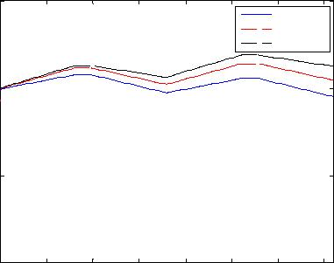

(e) Voltage of the supercapacitor

 | 11
 | 10.5 |  |  |  |  |  |  |  | Condition 1
 | 10.5 |  |  |  |  |  |  |  | Condition 2
 | 10 |  |  |  |  |  |  |  | Condition 3
 | 9.5
 | 9
Ib(A) | 8.5
 | 8
 | 7.5
 | 7
 | 6.5
 | 6 | 1610 | 1620 | 1630 | 1640 | 1650 | 1660 | 1670 | 1680 | 1690 | 1700
 | 1600
 |  |  |  |  |  | t(s)
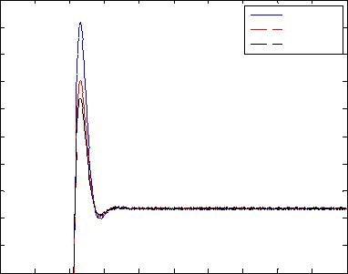

 | 50
 |  |  |  |  |  |  | Condition 1
 | 40 |  |  |  |  |  | Condition 2
 |  |  |  |  |  |  | Condition 3
 | 30
 | 20
Isc(A) | 10
Isc(A) | 0
 | -10
 | -20
 | -30
 | -40₀ | 1000 | 2000 | 3000 | 4000 | 5000 | 6000 | 7000
 |  |  |  |  | t(s)
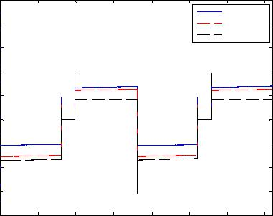

(c) Current of the supercapacitor

 | 0.65
 |  |  |  |  |  |  | Condition 1
 |  |  |  |  |  |  | Condition 2
ofchargeofbattery |  |  |  |  |  |  | Condition 3
ofchargeofbattery | 0.6
State | 0.55
 | 0.5 | 1000 | 2000 | 3000 | 4000 | 5000 | 6000 | 7000
 | 0
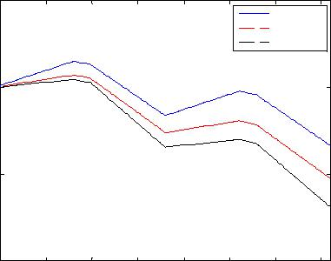
t

(f) Calculated state-of-charge of the battery
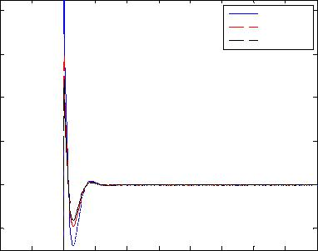

 | 8 |  |  |  |  |  |  |  | Condition 1
 |  |  |  |  |  |  |  |  | Condition 2
 |  |  |  |  |  |  |  |  | Condition 3
 | 6
 | 4
Isc(A) | 2
 | 0
 | -2
 | 1600 | 1610 | 1620 | 1630 | 1640 | 1650 | 1660 | 1670 | 1680 | 1690 | 1700
 |  |  |  |  |  | t(s)

(g) Zoomed version of bus voltage (h) Zoomed version of battery current (i) Zoomed version of supercapacitor current

Fig. 9 Simulation results for a hybrid energy storage system under Control Strategy A as the power sharing ratio changes.

V. CONCLUSION

A hybrid energy storage system is proposed in this paper, which comprised of a battery and a supercapacitor bank. These two energy storage devices are connected to a common DC voltage bus through two corresponding DC/DC power converters. Generally, the active hybrid energy storage system is used together with a main power source whose function is to provide average power to the load. The load is directly connected to the DC voltage bus through appropriate power converters. The battery and supercapacitor, as energy buffers, provide transient power and peak load requirement. This paper presents three different control strategies for power sharing between the battery and the supercapacitor. These control strategies are verified and compared against each other under certain operating conditions. Simulation results show that the battery loses most charge and the supercapacitor has the most charge in the process under Control strategy A; the battery has the most charge and the supercapacitor loses most charge in the process under Control strategy B. The effects of controller parameter variations on the system performance are also studied. Simulation results demontrate that the battery loses the least charge after 2 hours operation in Condition 1 compared with other two conditions. This is because the battery gets most charging current and discharges the least current in Condition 1. It is necessary to choose an appropriate set of parameters for the controller so as to operate the hybrid energy storage systems more efficiently and effectively in different scenarios.

ACKNOWLEDGMENT

This work was supported in part by the National Science Foundation under grants ECCS-0652300, ECCS-0748032 and ECCS-0821126.

REFERENCE

- G. Martin, “Renewable energy gets the "green" light in Chicago”, IEEE Power and Energy Magazine, Vol. 1, No. 6, pp: 34-39, Nov.-Dec. 2003.
- J. T. Bialasiewicz. “Renewable Energy Systems With Photovoltaic Power Generators: Operation and Modeling”, IEEE Transactions on Industrial Electronics, Vol. 55, No. 7, pp: 2752-2758, Jul. 2008.

- R. Karki, R. Billinton, “Reliability/cost implications of PV and wind energy utilization in small isolated power systems”, IEEE Transactions on Energy Conversion, Vol. 16, No. pp: 368-373, 4, Dec. 2001.
- C.L. Kana, M. Thamodharan, A. Wolf, “System management of a wind-energy converter”, IEEE Transactions on Power Electronics, Vol. 16, No. 3, pp. 375-381, May 2001.

- M. Harfman-Todorovic, M. Chellappan, L. Palma, P. Enjeti, “The role of supercapacitors in designing fuel cell powered portable applications”, IEEE Power Electronics Specialists Conference, pp: 2465-2472, Jun. 2008.

- J. McDowall, “Conventional battery technologies-present and future” IEEE Power Engineering Society Summer Meeting, Vol. 3 16-20, pp. 1538-1540, July 2000.
- K. Yoshimoto, T. Nanahara, G. Koshimizu and Y. Uchida, “New Control Strategy for Regulating State-of-Charge of a Battery in Hybrid

Wind Power/Battery Energy Storage System”, IEEE Power Systems Conference and Exposition PES, pp. 1244-1251, 2006.
- S. Duryea, S. Islam, W. Lawrance, “A battery management system for stand-alone photovoltaic energy systems”, IEEE Industry Applications Magazine, Vol. 7, No. 3, pp: 67-72, May-Jun. 2001.
- R. F. Nelson, “Power requirements for batteries in hybrid electric vehicles”, Journal of Power Sources, Vol. 91, No. 1, pp. 2-26, Nov. 2000.
- W. Lhomme, P. Delarue, P. Barrade, A. Bouscayrol and A. Rufer, “Design and Control of a supercapacitor storage system for traction applications”, Industry Applications Conference Fourtieth IAS Annual Meeting, Vol. 3, 2-6, pp. 2013-2020, Oct. 2005.

- A. Rufer and P. Barrade, “A Supercapacitor-based Energy-Storage System for Elevators with Soft Commutated Interface”, IEEE Transactions on Industry Applications, Vol. 38, No. 5, pp. 1151-1159, Sept.-Oct. 2002.

- M. B. Camara, H. Gualous, F. Gustin and A. Berthon, “Design and New Control of DC/DC Converters to Share Energy Between Supercapacitors and Batteries in Hybrid Vehicle”, IEEE Transactions on Vehicular Technology, Vol. 57, No. 5, pp:2721-2735, 2008.

- H. Yoo, S.-K. Sul, Y. Park and J. Jeong, “System Integration and Power-Flow Management for a Series Hybrid Electric Vehicle Using Supercapacitors and Batteries”, IEEE Transactions on Industry Applications, Vol. 44, No. 1, pp. 108-114, Jan.-Feb. 2008.

- P. B. Jones, J. B. Lakeman, G. O. Mepsted, and J. M. Moore, “A hybrid power source for pulse power applications”, J. Power Sources, Vol. 80, No. 1-2, pp. 242-247, Jul. 1999.

- L. Gao, Z. Jiang and R. A. Dougal, “An actively controlled fuel cell/battery hybrid to meet pulsed power demands”, J. Power Sources, Vol. 130, No. 2, pp. 202-207, May 2004.
- Z. Jiang, L. Gao, and R. A. Dougal, “Design and experimental tests of control strategies for active hybrid fuel cell/battery powerr sources”, J. Power Sources, Vol. 130, No. 1, pp. 163-171, May 2004.
- L. Gao, R. A. Dougal, S. Liu, “Active power sharing in hybrid battery/capacitor power sources”, IEEE Applied Power Electronics Conference and Exposition, Vol. 1, 9-13, pp: 497-503, 2003.

- Z. Jiang, L. Gao, and R. A. Dougal, “Design and experimental tests of control strategies for active hybrid fuel cell/battery powerr sources”, J. Power Sources, Vol. 130, No. 1, pp. 163-171, May 2004.
- Z. Jiang, R. A. Dougal, “Control strategies for active power sharing in a fuel-cell-powered battery-charging station”, IEEE Transactions on Industry Applications”, Vol. 40, No. 3, pp: 917-924, May-Jun. 2004.

- P. Thounthong, S. Rael, B. Davat, “Control Strategy of Fuel Cell and Supercapacitors Association for a Distributed Generation System”, IEEE Transactions on Industrial Electronics, Vol. 54, No. 6, pp: 3225-3233, Dec. 2007.

- S. M. Lukic, J. Cao, R. C. Bansal, F. Rodriguez, A. Emadi, “Energy Storage Systems for Automotive Applications”, IEEE Transactions on Industrial Electronics, Vol. 55, No. 6, pp: 2258-2267, Jun. 2008

